**TASK 4:**

**Task Description 👨🏻‍💻**

**🔹 Launch an AWS instances with the help of ansible**

**🔹 Retrieve the public IP which is allocated to the launched instance.**

**🔹 With the help of the retrieved Public IP configure the load balancing setup using haproxy**

**CREATING A LOADBALANCER USING ANSIBLE**

## **Step 1: Prerequisites**

* **To install boto3 module**
* **Setting up the dynamic inventory using python code**
* **chmod +x filename.yml**
* **Creating multiple roles loadbalancer and session14**

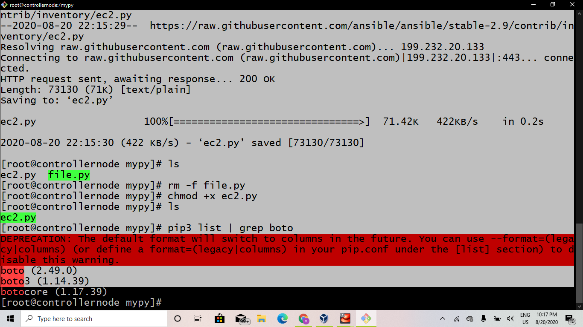

## 

## **Step 2: Launching an AWS Instance using ansible**

## 

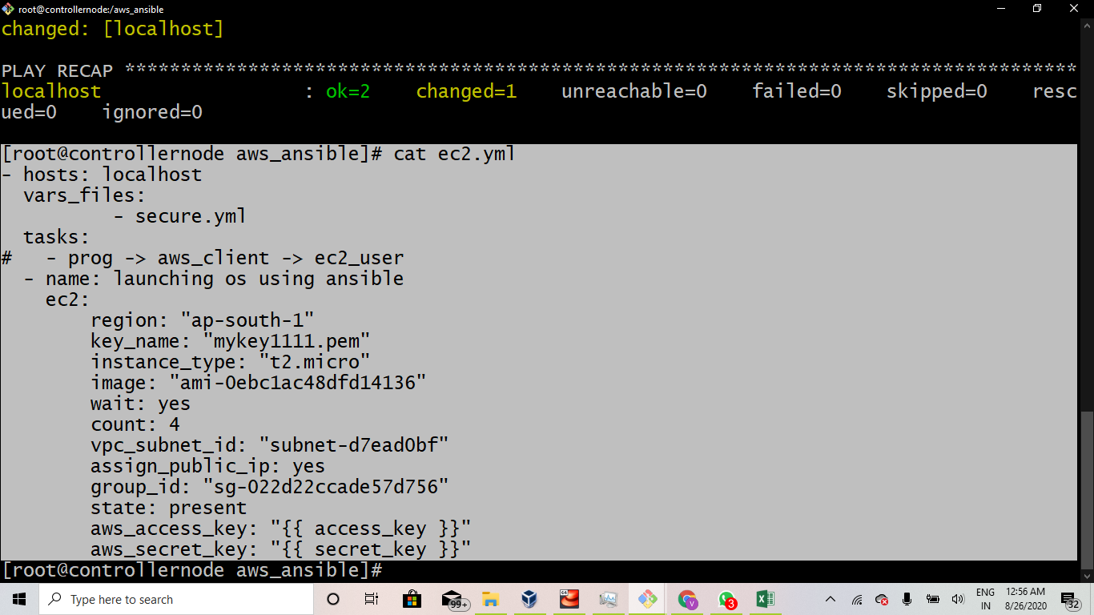

## **Creating an task4.yml file**

## **Storing access_key and secret_key in a separate vault file**

## **Using ansible-playbook --ask-vault-pass task4.yml**

## 

## 

## **Step 3: Setting up the Dynamic inventory environment**

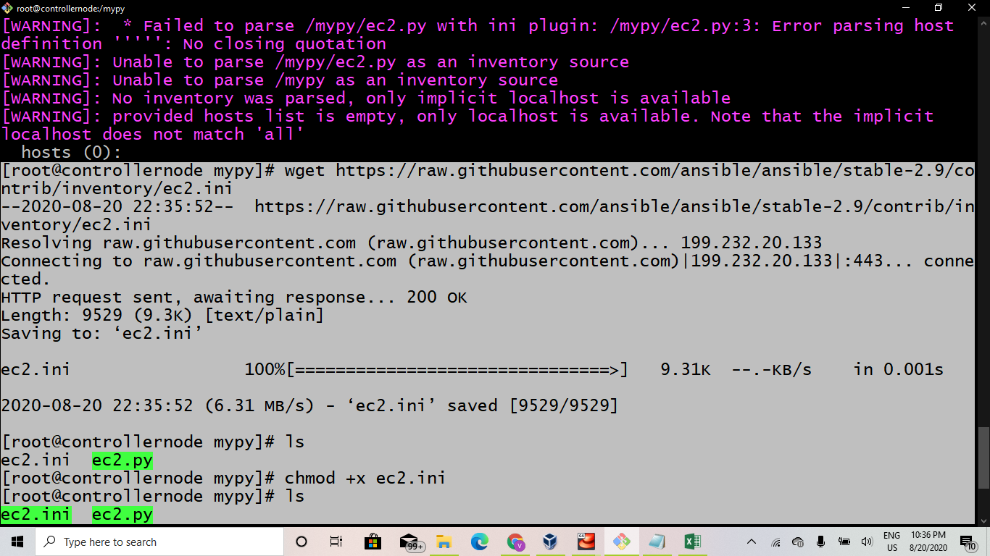

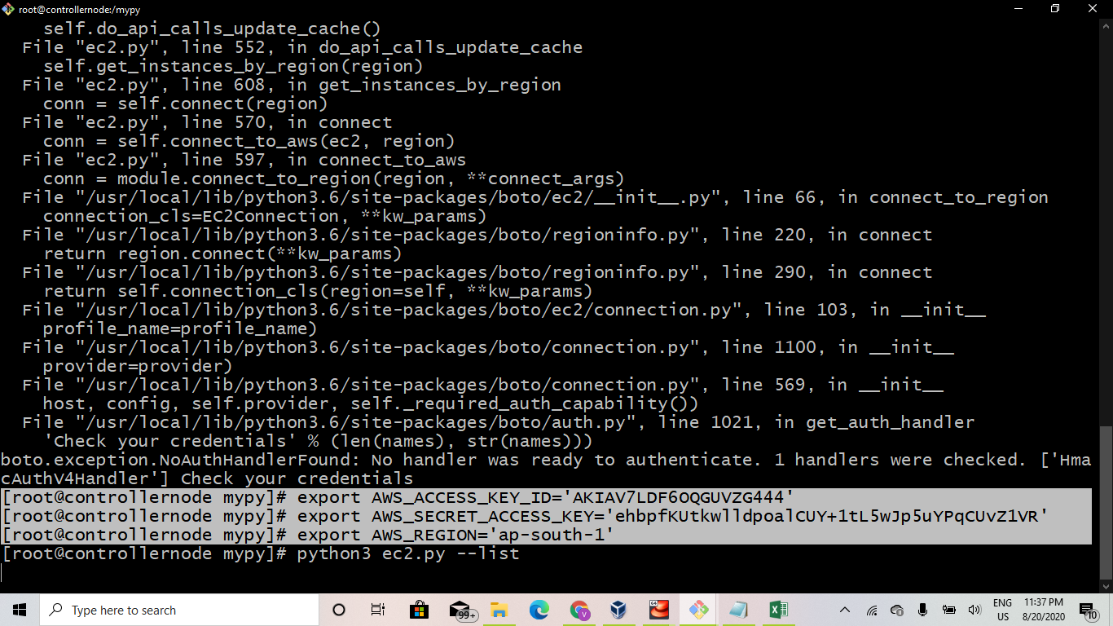

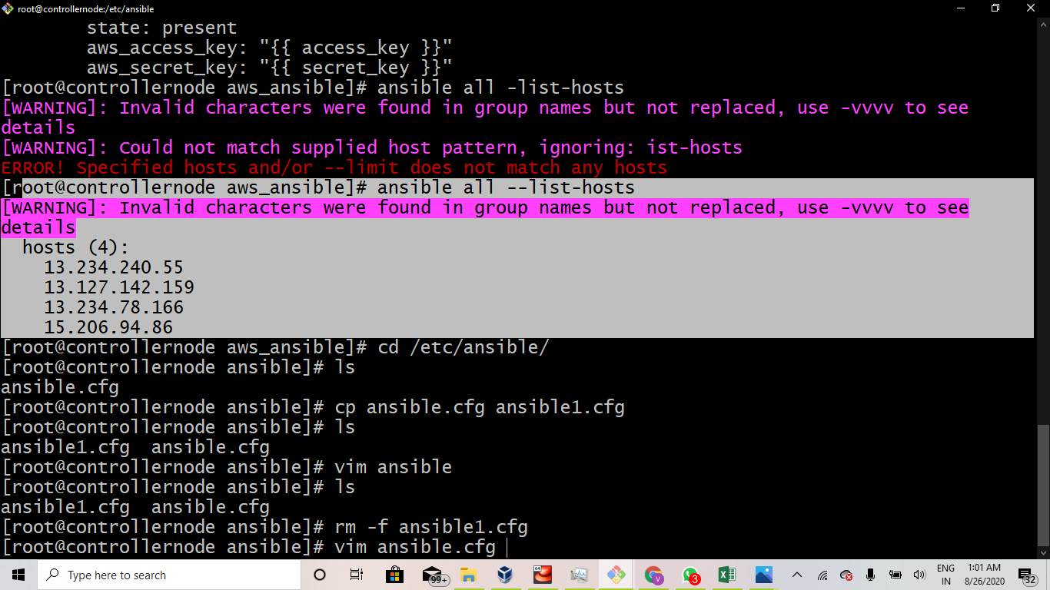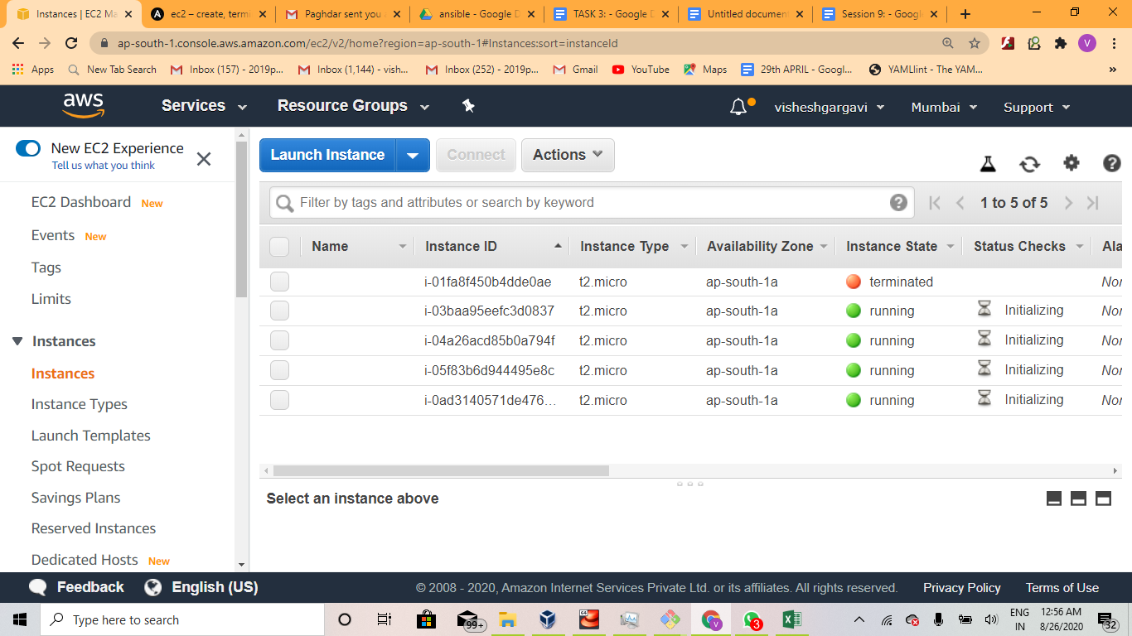

## **Step 4: Connect Instance with SSH**

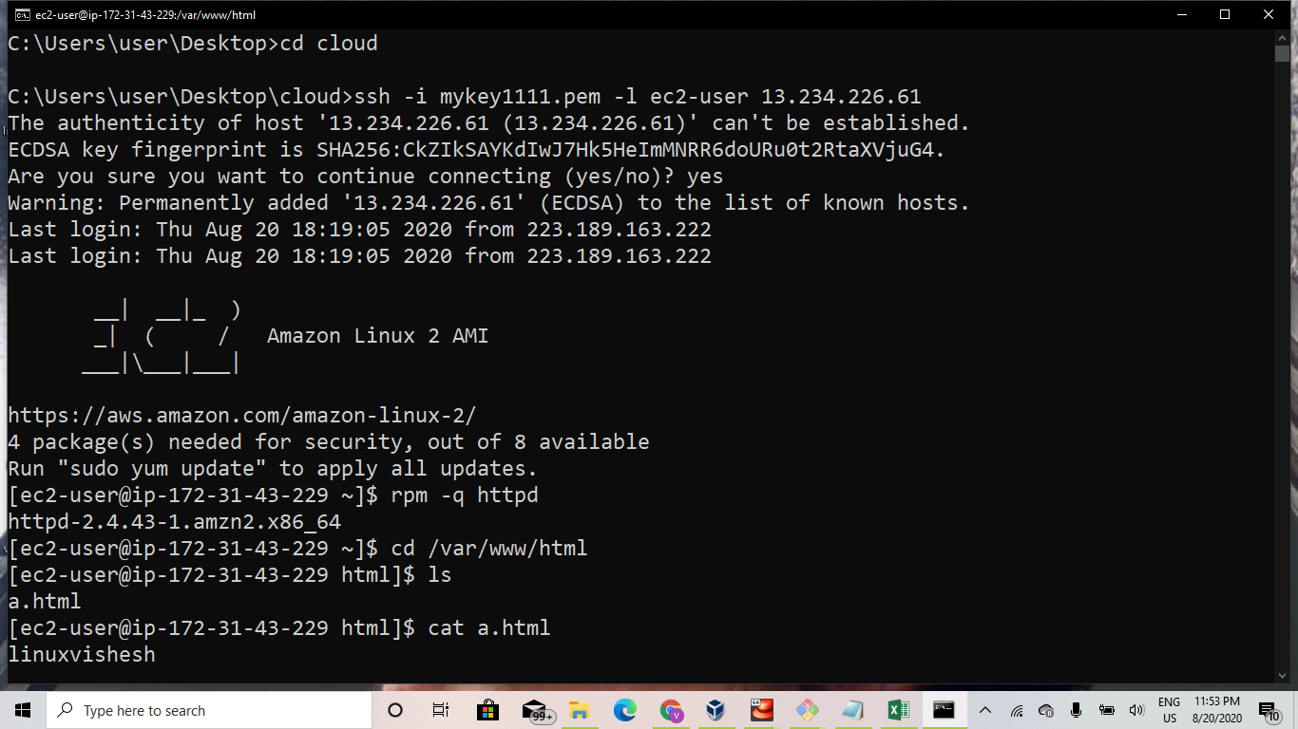

## **Step 5: Copying key-pair using win-scp**

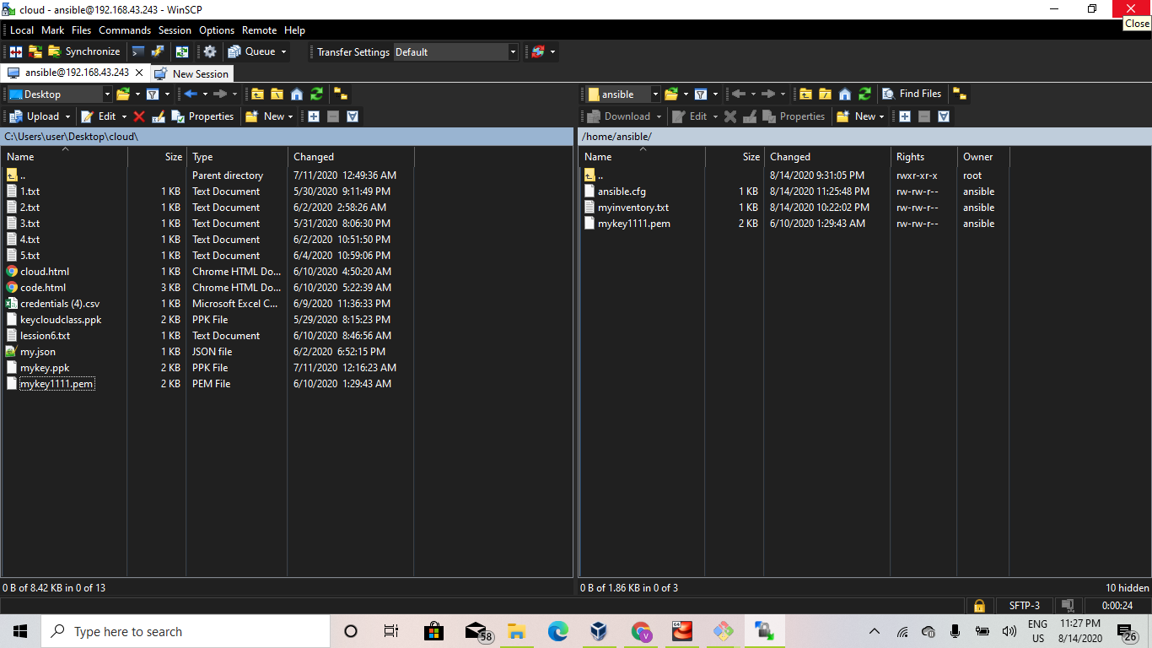

## 

## **Step 6: Configuring host and config file**

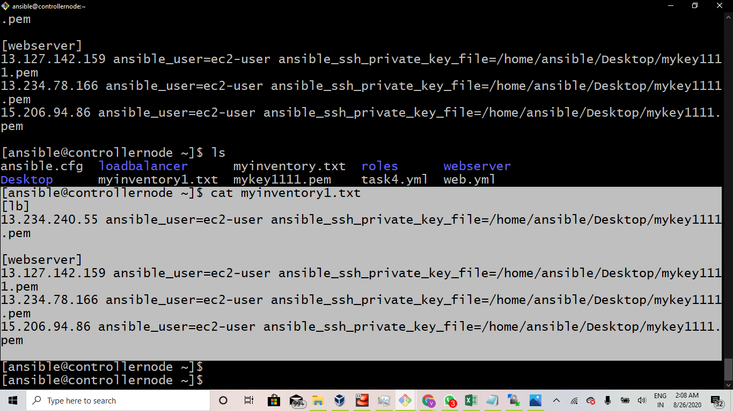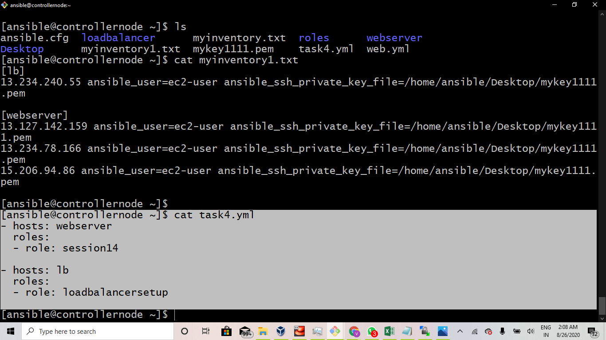

**The information you will need is:**

* **Name for the instance**
* **IP Address of your AWS instance(public-ip)**
* **The user present on your AWS instance (ec2-user)**
* **Location to your private key (.pem) file**

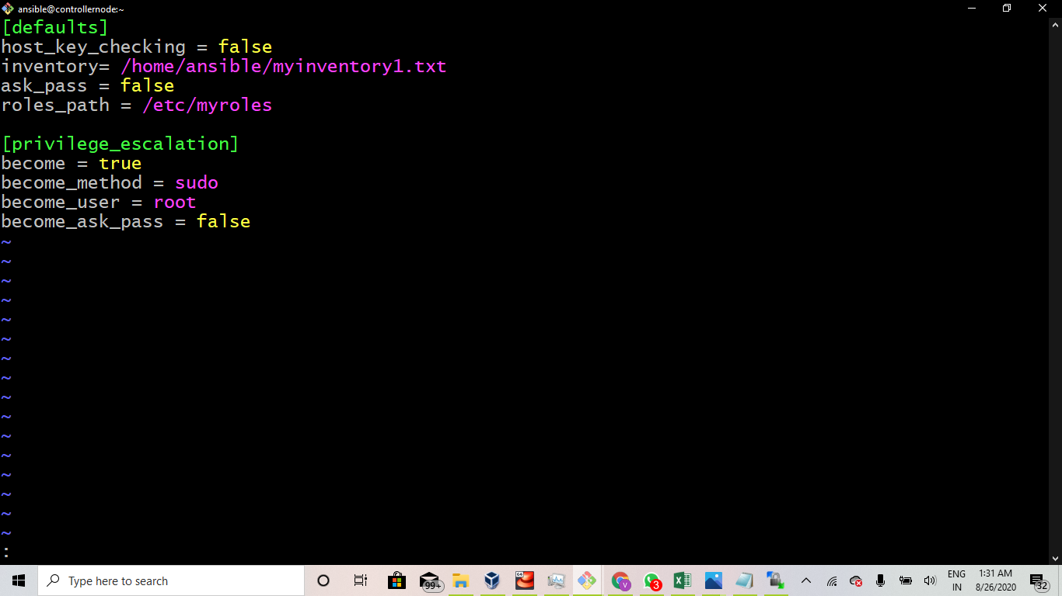

## **Step 7: Configuring the setting and making public-key to private**

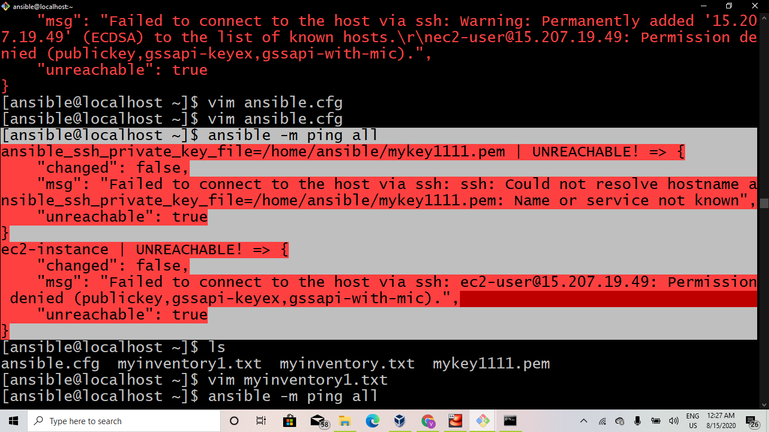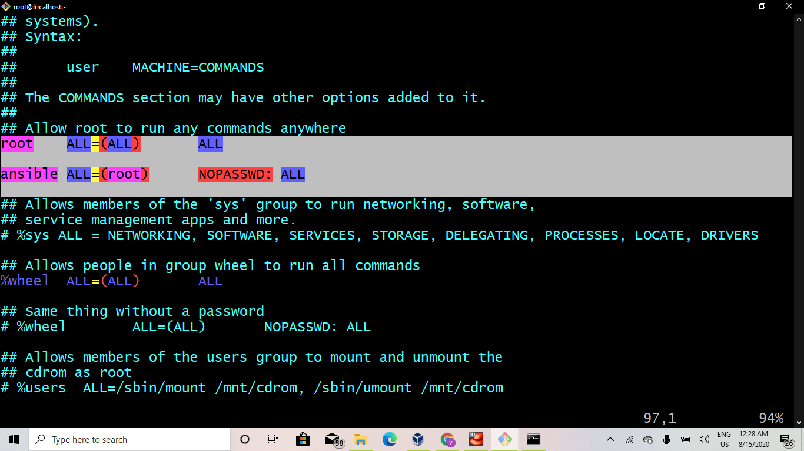

**sudo chmod 600 /home/ansible/mykey1111.pem**

**sudo chmod 755 ~/.ssh**

## **Step 8: Run Ansible Ping Module**

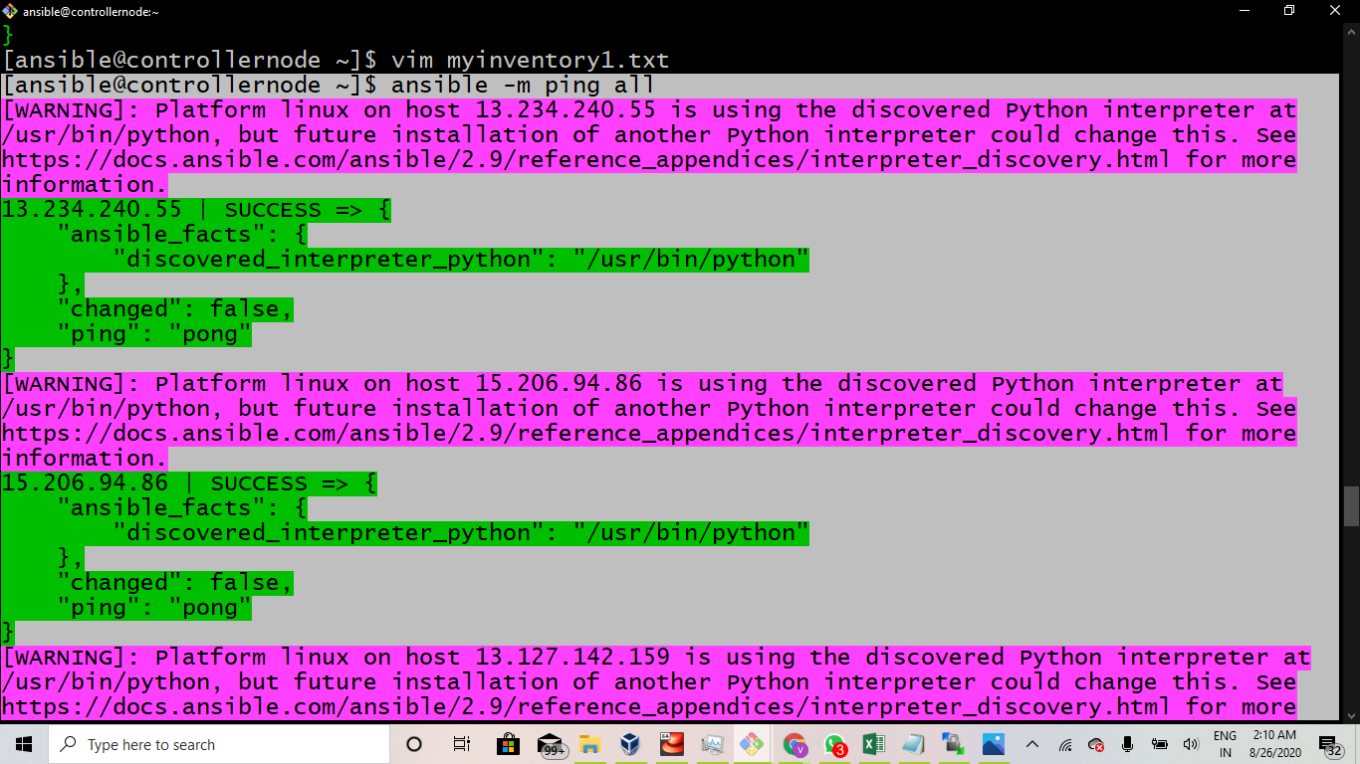

## **Step 9: Creating roles load balancer and session14**

## **Step 10: Configuring Haproxy service inside the load balancer role**

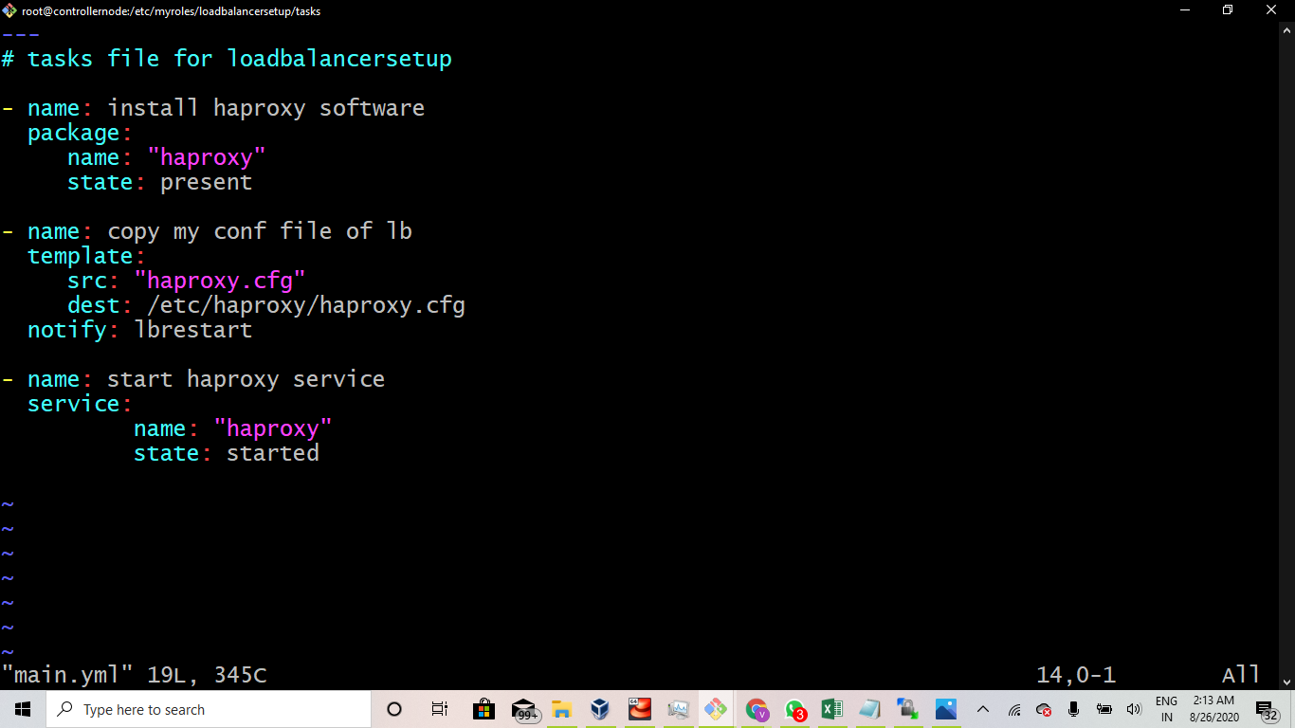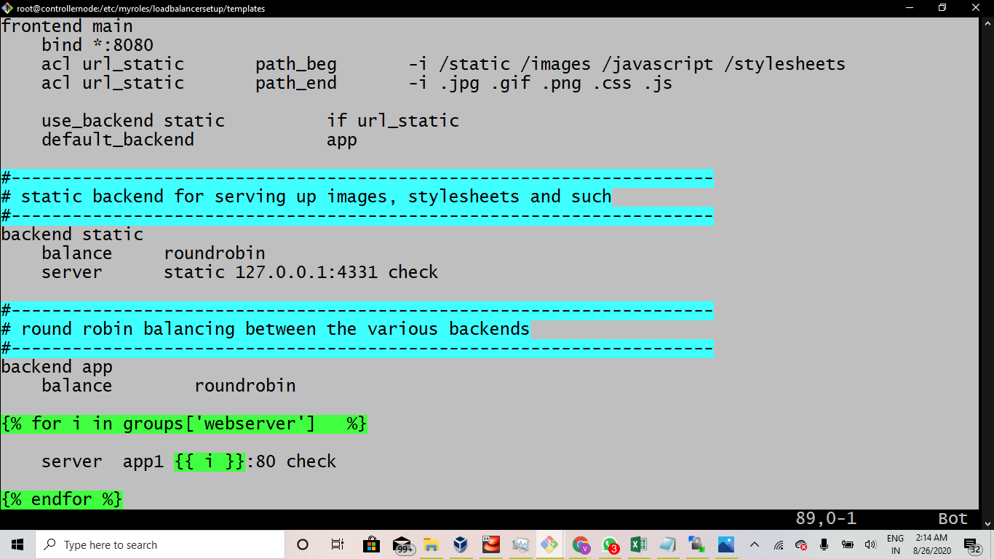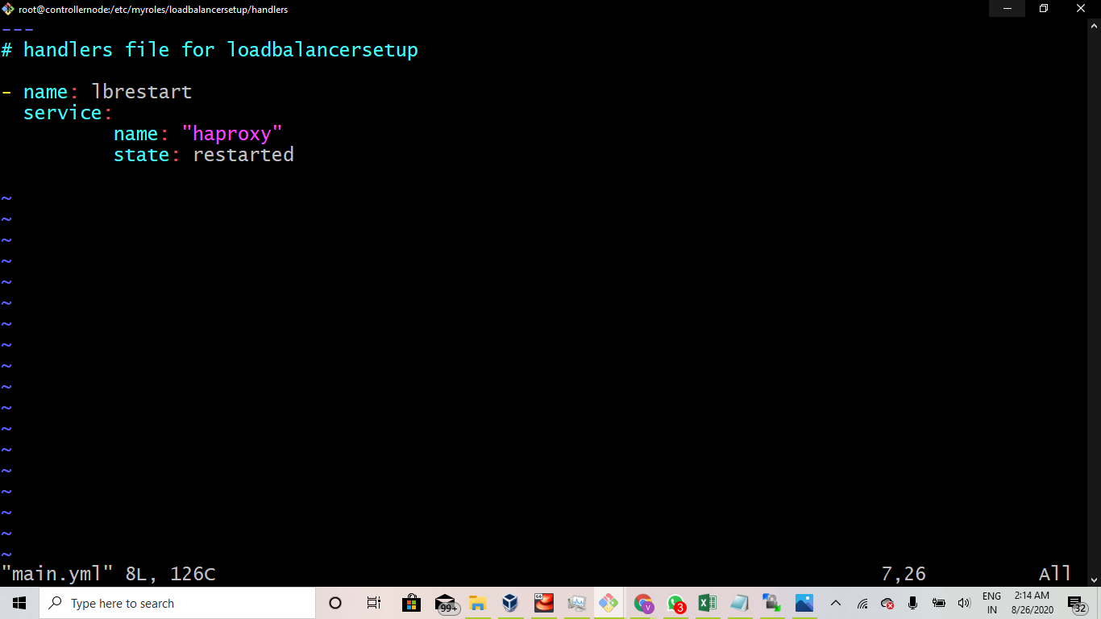

## **Step 11: Configuring httpd server inside the session14 role**

## **Step 12: Running ansible-playbook command**

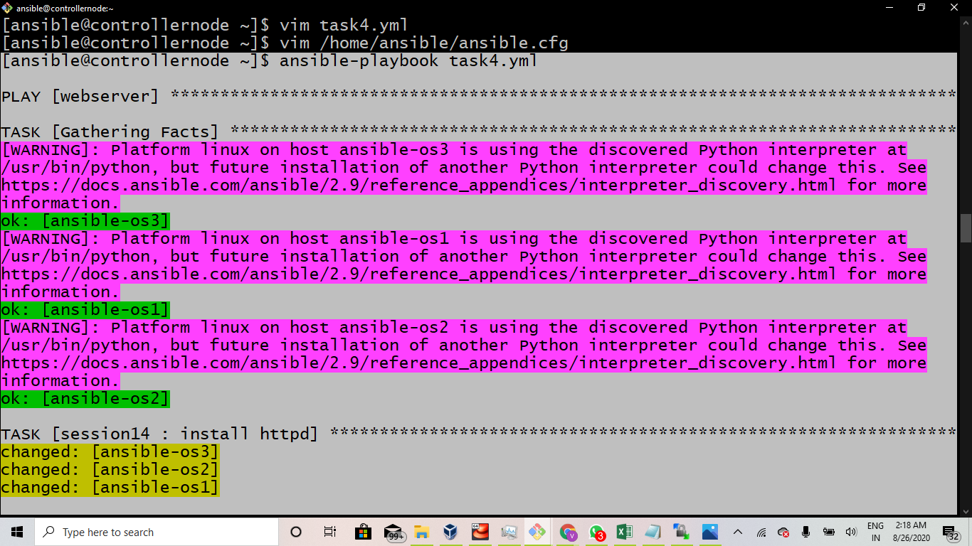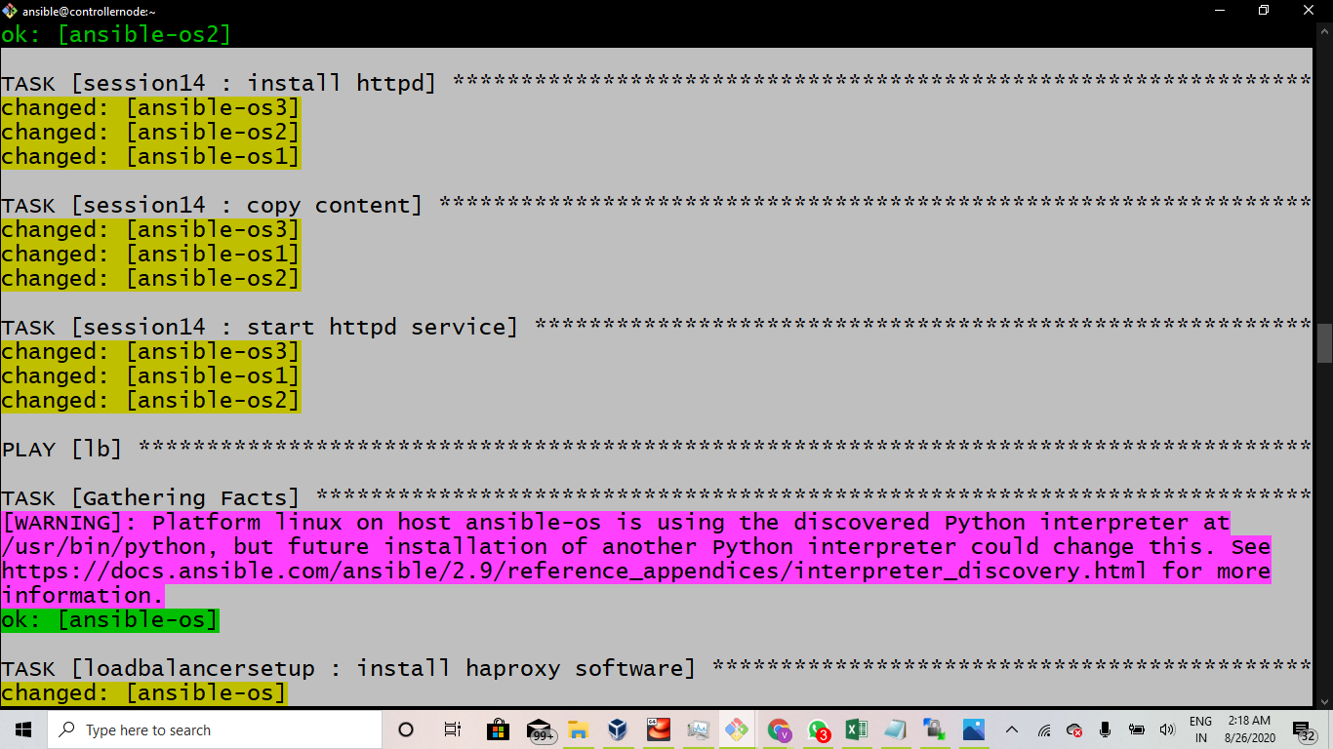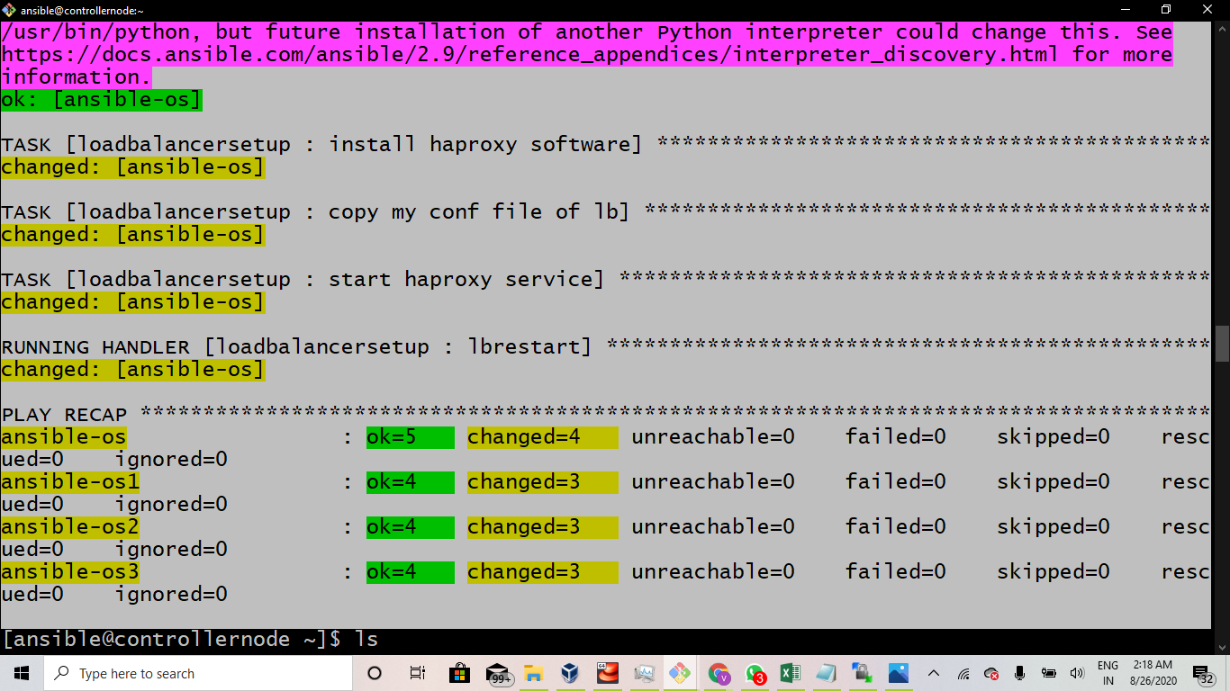

## **Step 13: final Evaluation**

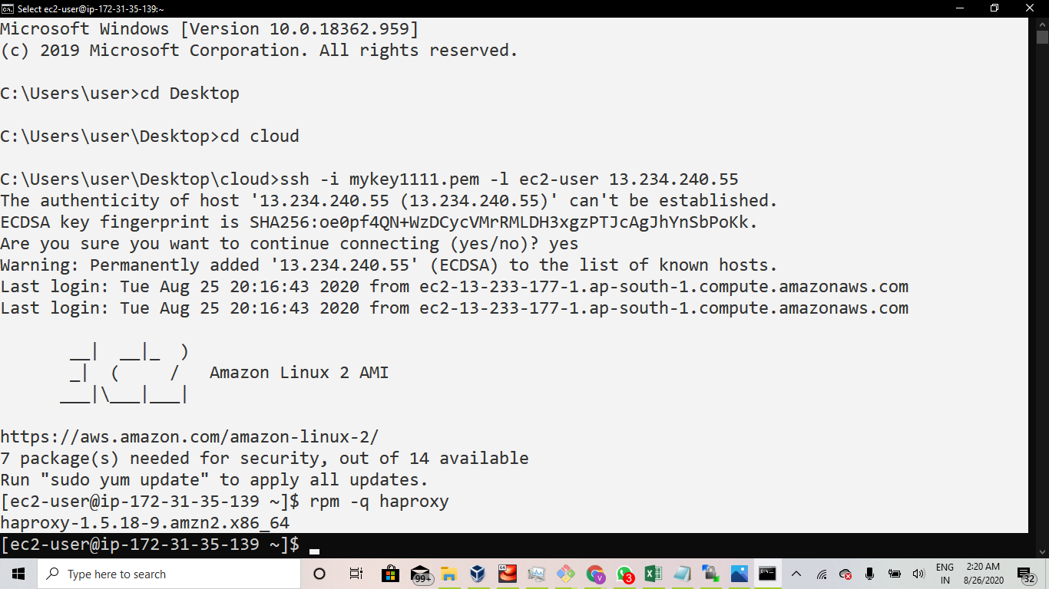

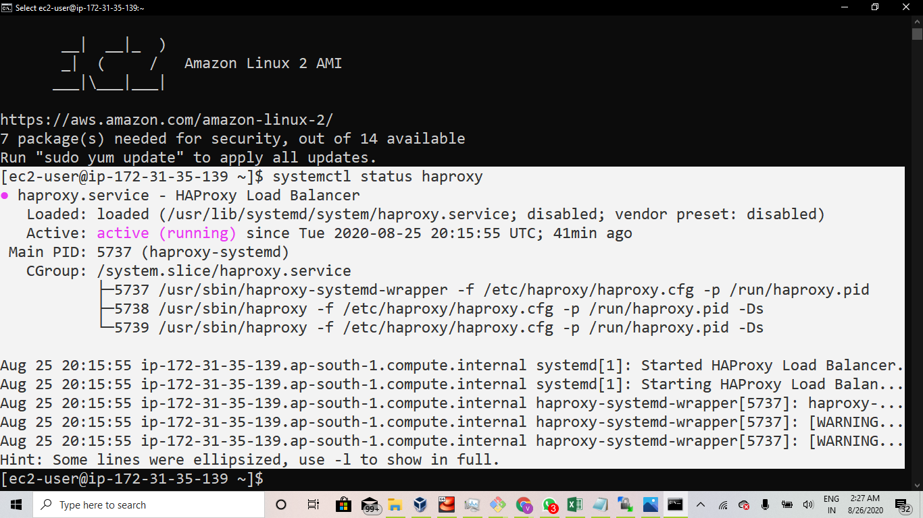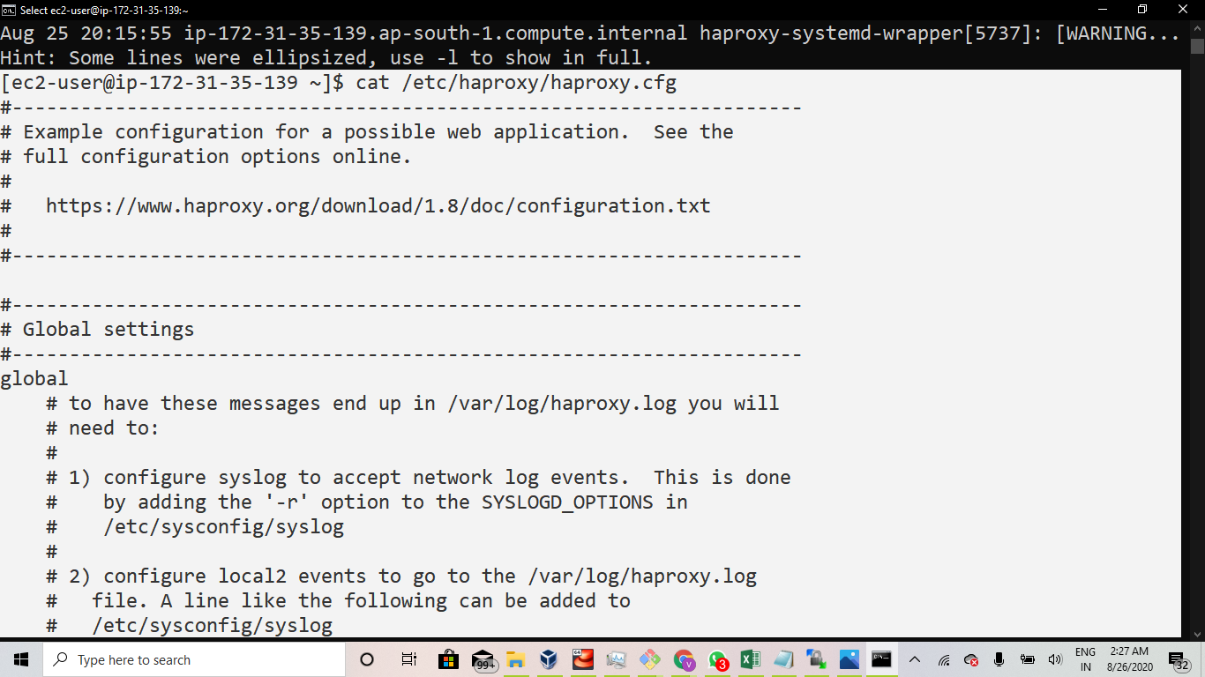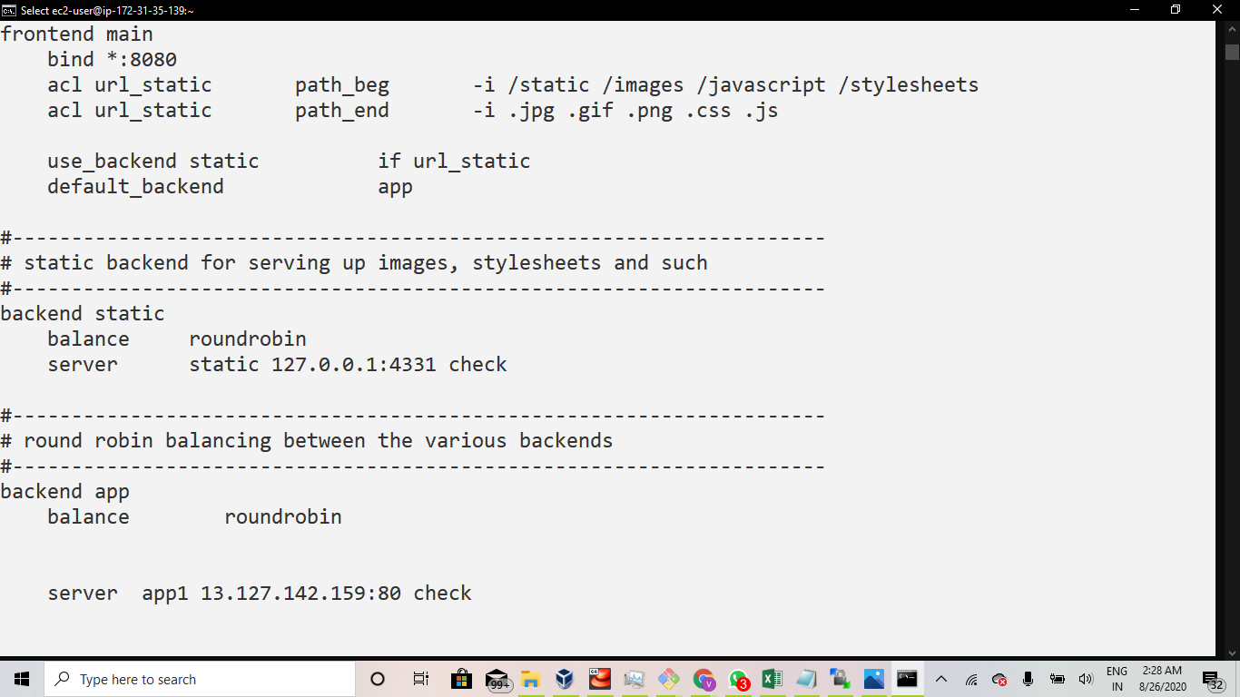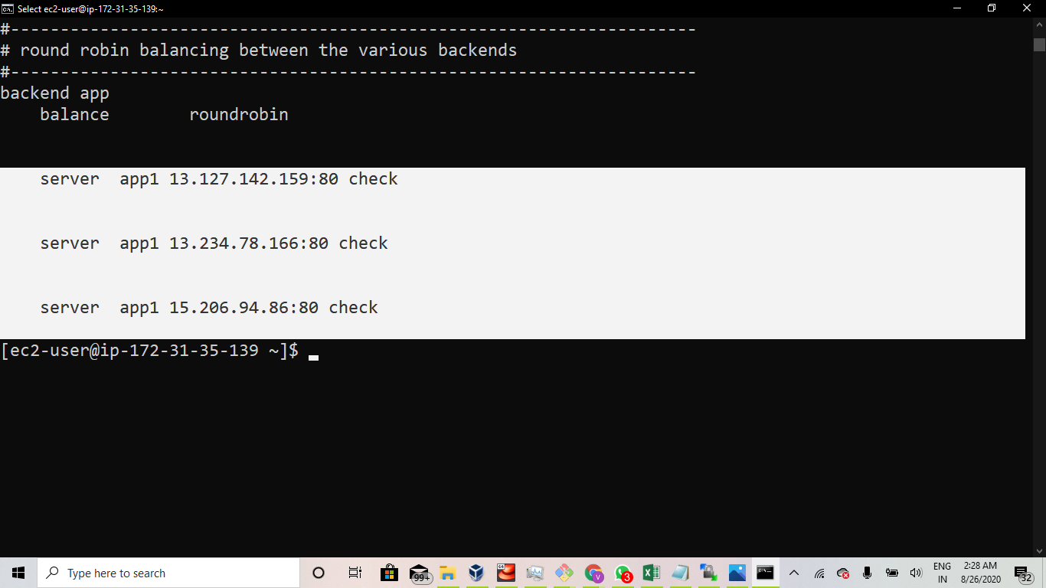

## **Step 14: Outputs**

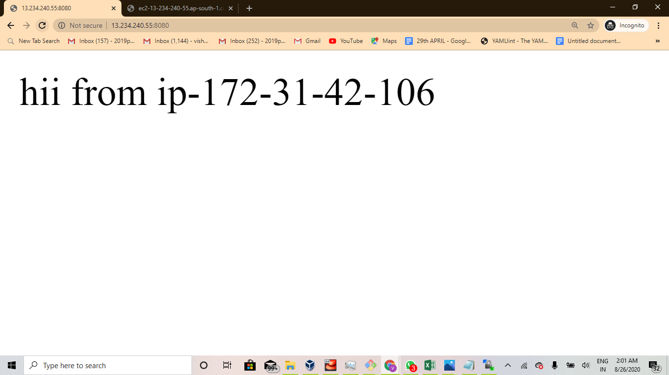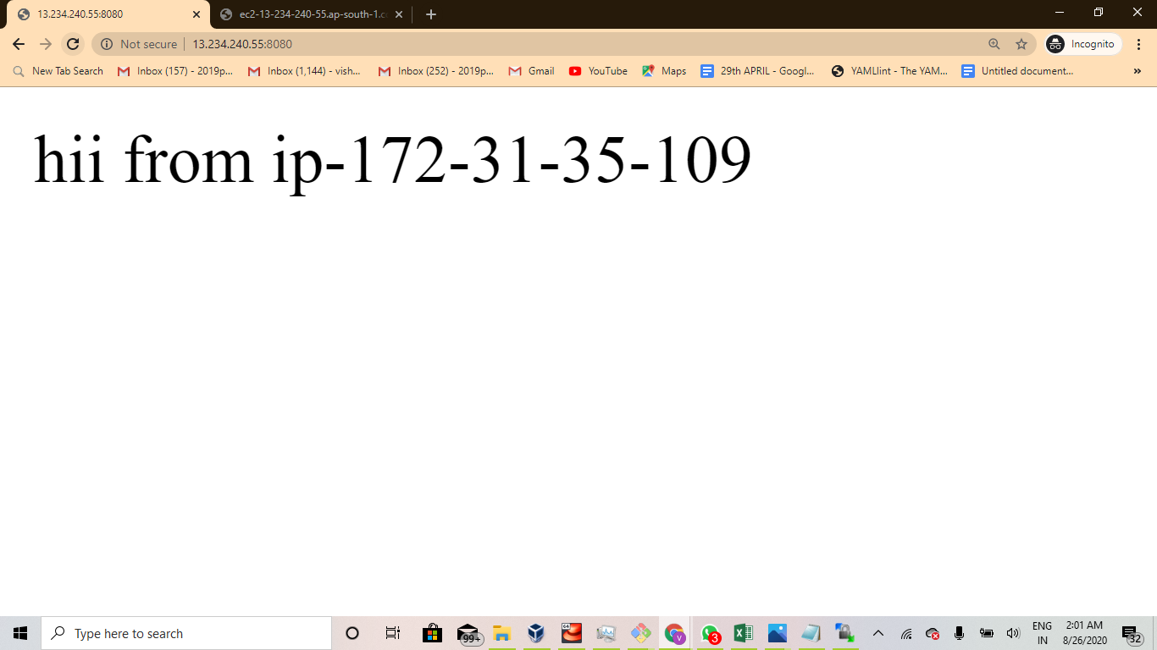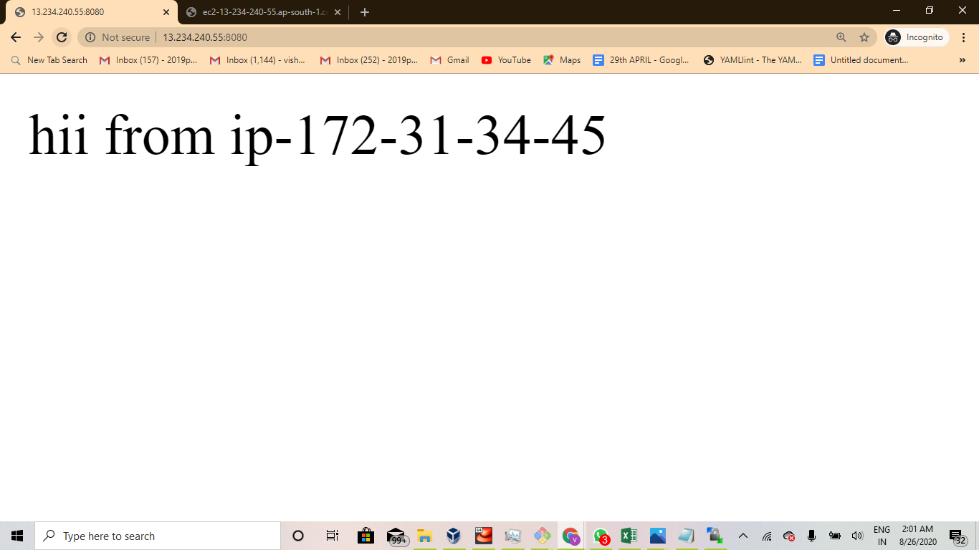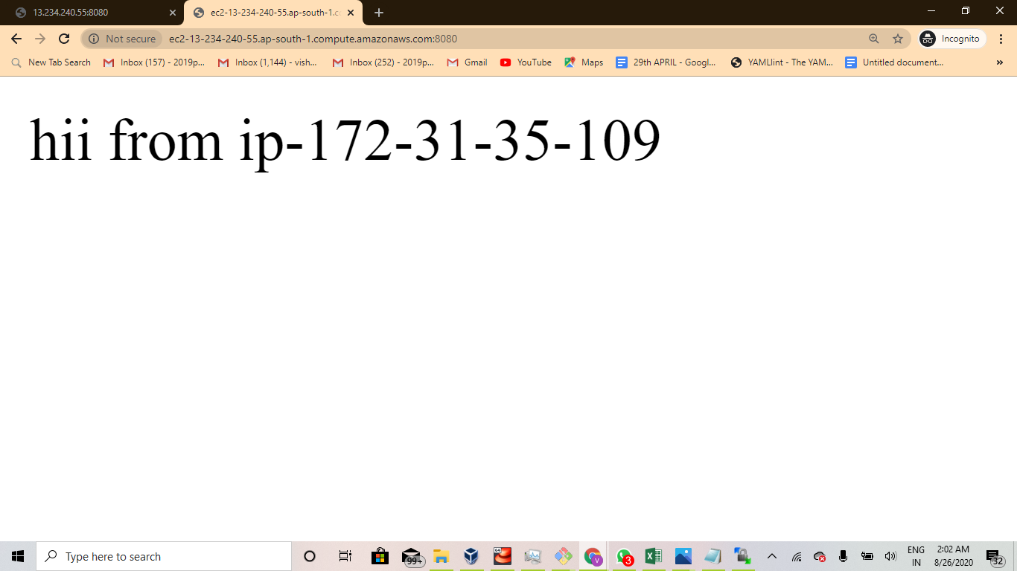

## **Note:**

Allow all the traffic and launch the instances in the default vpc

Thanks